Lab Manual of Wireshark with Practicals

Task-1: List the different protocols that appear in the protocol column in the unfiltered packet-listing window in step 7 above.

The following protocols were observed:
- TCP
- TLSv1.2
- DNS
- TLSv1.3
- UDP
- ICMPv6
- ARP
- MDNS

Task-2: How long did it take from when the HTTP GET message was sent until the HTTP OK reply was received?
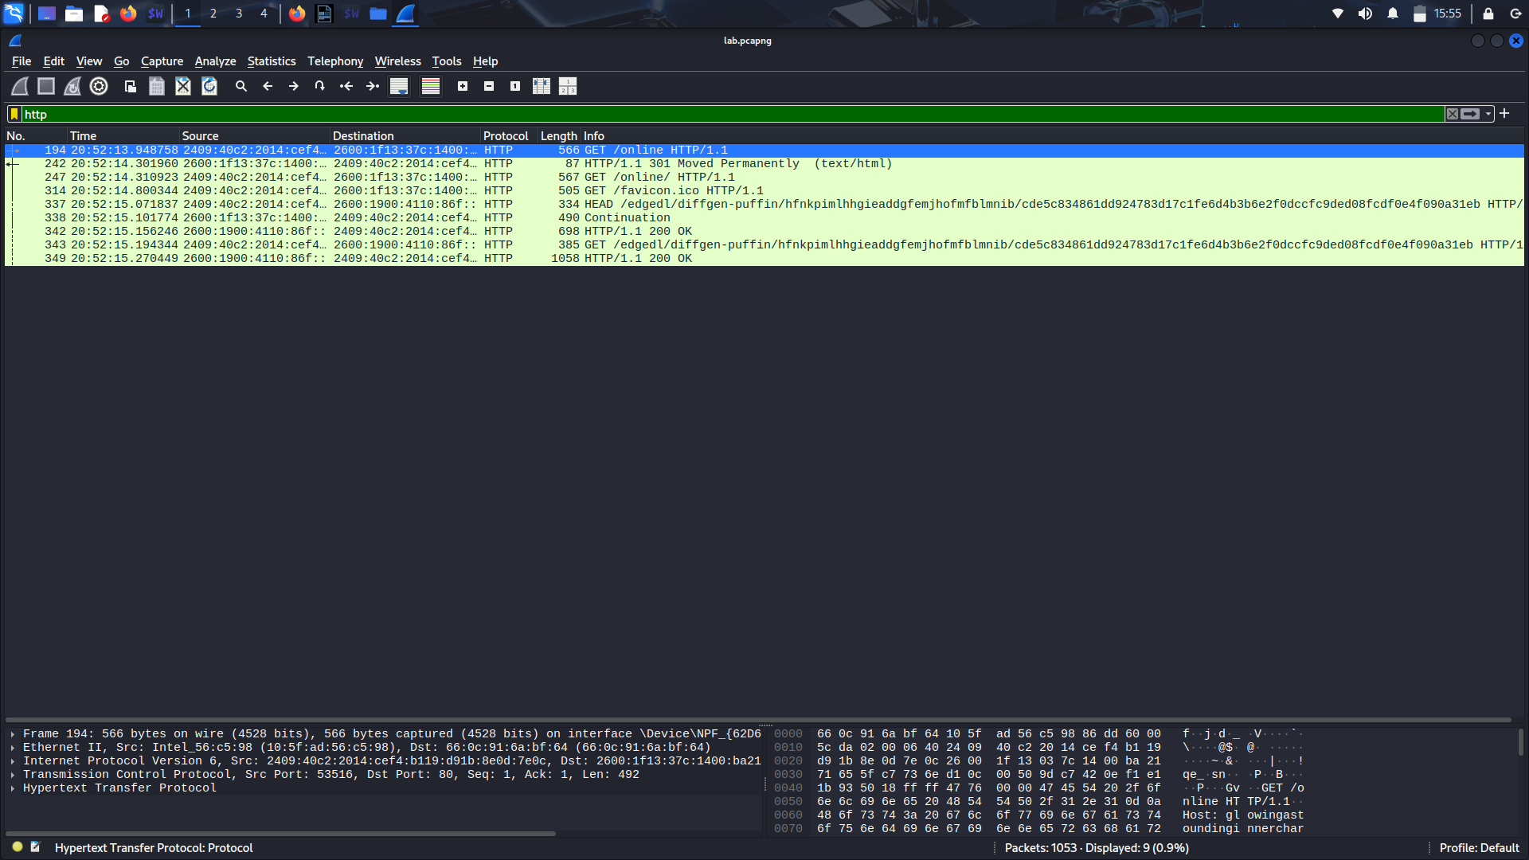
- Time at GET request = 20:52:14.800344 s
- Time at HTTP 200 OK = 20:52:15.156246 s

Task-3 : What is the Internet address of the gaia.cs.umass.edu (also known as www-net.cs.umass.edu)? What is the Internet address of your computer?
- Internet Protocol Version 6, Src:2409:40c2:2014:cef4:b119:d91b:8e0d:7e0c,
Dst: 2600:1f13:37c:1400:ba21:7165:5fc7:736e

Task-4 : Print the two HTTP messages displayed in step 9 above. To do so, select Print from the Wireshark File command menu, and select “Selected Packet Only” and
“Print as displayed” and then click OK.

- As per the task, i have created a printed file for the “Selected packet only” and it is being attached with the lab assignement pdf as mentioned in the task.

